Trade of Sheet Metalwork
Module 3: | Thermal Processes
Unit 9: | Resistance Welding Spot Welding Lap Joint
 | Phase 2

Table of Contents
List of Figures 4
List of Tables 5
Document Release History 6
Module 3 – Thermal Processes 7
Unit 9 – Resistance Welding Spot Welding Lap Joint 7
Learning Outcome: 7
Key Learning Points: 7
Training Resources: 7
Key Learning Points Code: 7
Spot Welder 9
Care of Tips 10
Check Welding Faults 11
Ohm’s Law 12
What you have to do: 14
Self Assessment 15
Answers to Questions 1-3. Module 3.Unit 9 16
Index 18

List of Figures
Figure 1 - Spot Welding 8
Figure 2 - Spot Welder 9
Figure 3 - Electrodes 9
Figure 4 - Care of Tips 10
Figure 5 - Ohms Law Triangle 12

List of Tables

Document Release History
Date | Version | Comments
26/09/06 | First draft
08/04/14 | 2.0 | SOLAS transfer

Module 3 – Thermal Processes

Unit 9 – Resistance Welding Spot Welding Lap Joint
Duration – 3.5 Hours

Learning Outcome:
By the end of this unit each apprentice will be able to:
- Read drawing and interpret weld symbol
- Prepare material for spot welding
- Set-up spot welding machine
- Spot weld mild steel lap joints

Key Learning Points:
Rk | Weld symbol.
Sk | Resistance welding – basic principles, types.
Sk Rk | Spot welding machine – components, current setting timing, pressure and adjustments.
Rk Sk | Electrodes – preparation, care, positioning.
Rk Sk | Preparation of materials.
Sk | Positioning of work pieces.
Rk | Weld defects and causes.
Rk | Slug test.
Sc | Electricity, basic theory – ohms law.

Training Resources:

- Toolkit
- 1.0 mm mild steel sheet
- Spot welding machine
- Figure 1
- Files and abrasive strip

Key Learning Points Code:
M = Maths D= Drawing RK = Related Knowledge Sc = Science
P = Personal Skills Sk = Skill H = Hazards

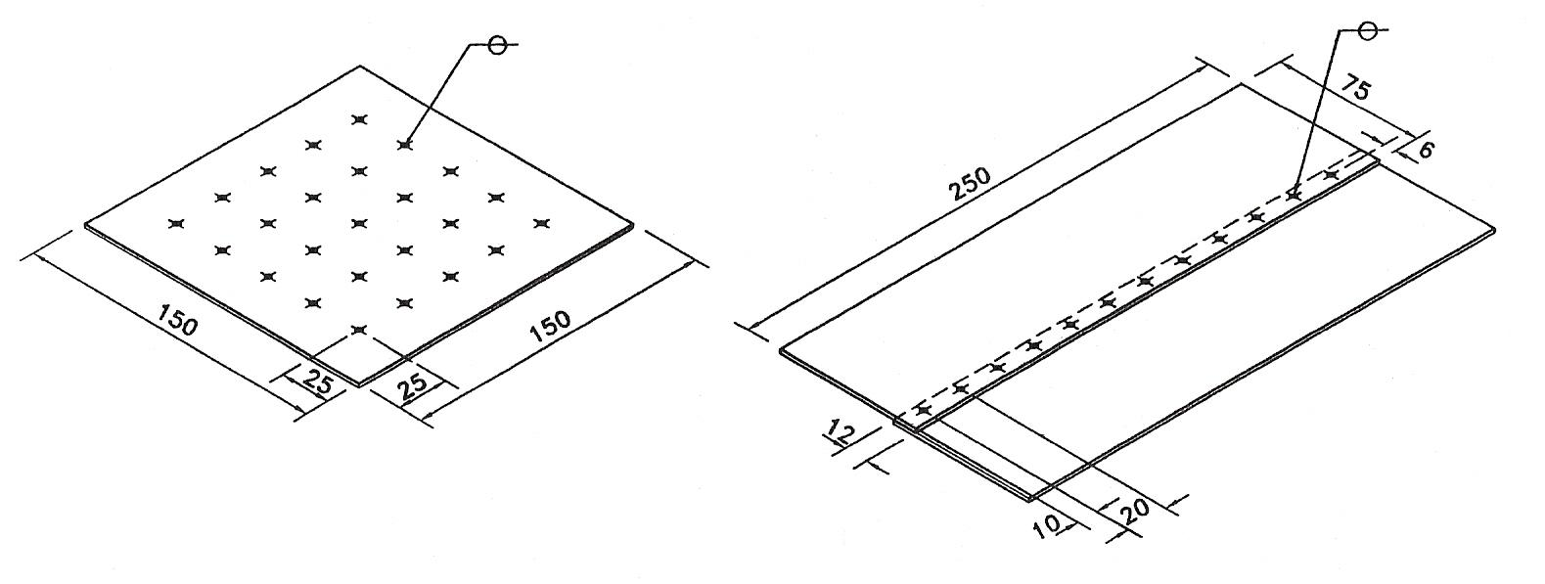
Figure 1 - Spot Welding

Spot Welder
Commonly used as an alternative to riveting for jointing thin plate and light gauge metal. The spot welder has control over the three adjustments, current flow, timing of weld and pressure applied. Adjustment can also be made to the arms of electrode holders, to accommodate various shapes of work. Electrodes can be obtained in vertical and offset form.
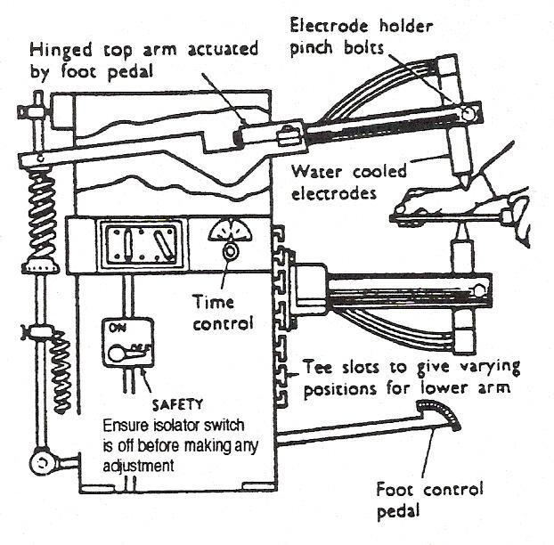
Figure 2 - Spot Welder

Electrodes are generally made of copper, for certain classes of work they may be tipped with harder material i.e. tungsten or copper alloy. Electrodes are generally water cooled, with the water supplied through the hollow electrodes. Care should be taken when changing electrodes not to damage the tapered seating.
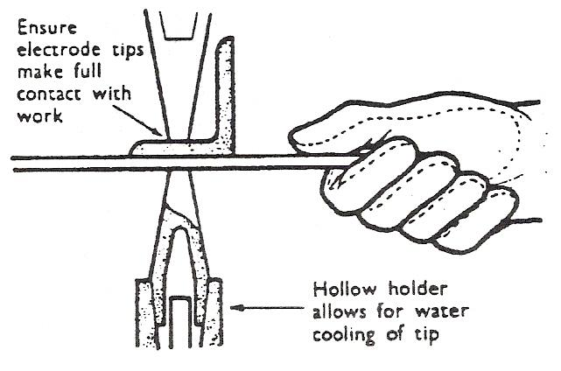
Figure 3 - Electrodes
Tips should be flat, and for general use have a tip diameter of 3/16" - 3/8", 4 mm - 7 mm.
Spot welding or resistance welding is heat generated at the metal to be welded by the resistance given to the flow of electricity as it passes through the workpiece. The heat generated along with pressure supplied by the tips completes the weld; offset electrodes are available which increases the range of work which can be carried out.

Care of Tips
Spreading of the tip or pitting, due to prolonged use, may be rectified by careful use of a smooth file. Should spreading be excessive, tips should be removed for bectification. File carefully round electrode to reduce face area.
File face to remove pits and ensure full even contact.
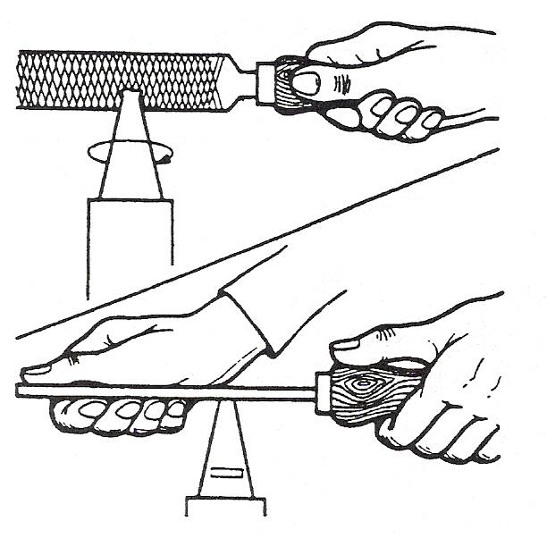
Figure 4 - Care of Tips

To get an acceptable weld three things must be right: the current should not be too high or too low; the timer not too long or too short and the pressure set right.
If there is a cooling system it must be turned on. While operating a spot welder you should remove your watch as it may become magnetised. The metal to be welded must be clean - if the weld pool becomes contaminated it weakens the weld.
Tips become hot and should not be touched.
To check strength of spot weld we apply the slug test: spot weld two pieces of metal together and pull apart. If there is no apparent damage it is a sign of a bad spot weld. Some damage indicates a good weld.
Apart from spot welding there is also seam welding. The workpiece is held together under pressure by revolving circular electrodes. The result is a series of overlapping spot welds made progressively along the seam by the rotating electrodes. This method of welding is ideal for making seams on fuel tanks or containers.

Check Welding Faults
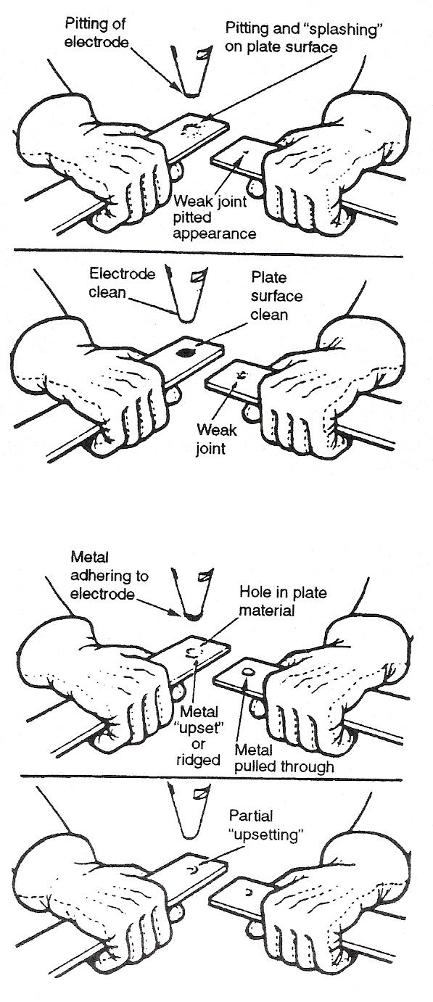
Before making any test, check the following:
- Time setting and current controls.
Weld two strips of appropriate material. Break joint by twisting. Examine weld. Pitting of the surface indicates that the current is being switched on before pressure is applied. To rectify, reset solenoid trip switch to give later control. A weak joint with clean surface is an indication that the pressure is too low. Increase pressure by adjusting hand nut.
Holes burned in one plate are an indication that the pressure is too high. To rectify, reduce pressure by adjusting hand nut.
Metal partially upset is an indication that the tips are not in full contact. File tips to rectify.

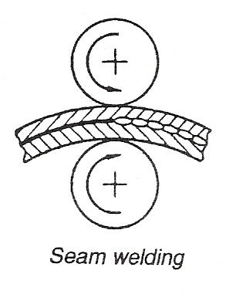

Ohm’s Law
A circuit contains voltage, current and resistance, these are all related to each other so that: a pressure of one volt will force a current of one amp, through a resistance of one Ohm.
This relationship is called "Ohms Law" and is normally shown as:
Voltage = Current x Resistance
V = I x R

Where: V = voltage in volts
I = current in amps (this sometimes uses the symbol A)
R = resistance in ohms (this sometimes uses the symbol R).

If you have any two of the three you can find the third, so that:
I = V/R, or R = V/I, or V = IR

An easy way of remembering this relationship is using the "Ohms Law" triangle.
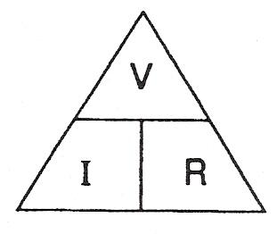
Figure 5 - Ohms Law Triangle

If you want to know how much current (I) is in a circuit you cover up the symbol so that current: I = V/R

If you want to know how much resistance (R) is in a circuit you cover up the symbol so that resistance: R = V/I

If you want to know how much voltage (V) is in a circuit you cover up the symbol so that voltage: V = I x R
- Determine how much current is flowing in a circuit if the voltage applied is 12V and the resistance of the circuit is 6 ohms.
Don't forget the triangle.
Answer:
Resistance = 6 ohms
Voltage = 12 volts
Current = ?

Using the "Ohms Law" triangle
I = V/R

I = 12/6

I = 2 amps

- Determine the total resistance of a circuit if the current flowing is 10 amps and the voltage is 12 volts.

Answer:
Voltage = 12 volts
Current = 10 amps
Resistance = ?

Using the "Ohms Law" triangle
R = V/I

R = 12/10

R = 1.2 ohms

What you have to do:
- Determine how much voltage we need to force a current of 3 amps through a circuit which has a resistance of 4 ohms.

Answer:
Current = 3 amps
Resistance = 4 ohms
Voltage = ?

Using the “Ohms Law” triangle
V = I x R

V = 3 x 4

V = 12 volts

Self Assessment
Questions on Background Notes – Module 3.Unit 9

1. What is the tip diameter for the copper electrodes?

2. What are the three settings to watch when spot welding?

- Draw “Ohms Law” triangle.

Answers to Questions 1-3. Module 3.Unit 9

1.

Tips should be flat and for general use have a tip diameter
of 3/16″ - 3/8″.

2.

- Time Setting
- Current Controls
- Pressure, too high/low with tips in full contact

3.

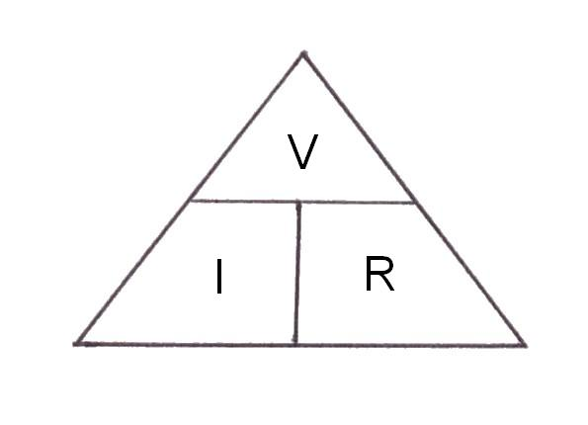

V = Voltage I = V / R
I = Current R = V/ I
R = Resistance V = I x R

Index

C
Care of Tips, 11
Check Welding Faults, 12
O
Ohm’s Law, 13
S
Self Assessment, 16
Spot Welder, 10
W
What you have to do:, 15

